Logical Entity-Relationship Diagram
KAVERI 3.0 — User Management & Role-Based Access Control

1. Document control
Field | Value
Document ID | ERD-K3-UM-001
Version | 2.1
Status | Draft / companion to BRD v4.18
Project | KAVERI 3.0 — Department of Stamps and Registration
Module | User Management & RBAC
Source BRD | Finalized BRD/User Management/BRD_User_Management_v4.18.docx
Relationship to BRD | Separate companion document — not a section of the BRD
Author (BA) | Nandha Kumar
Product Owner | Prashanth
Domain expert | Prabhakar Naik
Last updated | 2026-09-05
Physical DDL | Finalized BRD/User Management/DDL/ (PostgreSQL)

Version | Date | Summary
1.0 | 2026-08-30 | Initial logical ERD derived from User Management BRD v4.8 masters, FRs, and occupancy / RBAC rules.
2.0 | 2026-09-01 | Revised for BRD v4.16: requirement IDs aligned to FR-UM-nnn convention; logical model unchanged.
2.1 | 2026-09-05 | Aligned to BRD v4.18: TEMPORARY_ABSENCE and TEMPORARY_CHARGE (FR-UM-079–FR-UM-084); USER_SESSION context for temporary charge; companion PostgreSQL DDL scripts.

2. Purpose and scope
This document is the logical data model for the User Management module. It is issued as a stand-alone engineering / BA companion so that the BRD remains a requirements document. Physical DDL for PostgreSQL is provided alongside this ERD under DDL/; implementers may split or merge tables provided the business keys, cardinalities, and rules below are preserved.
In scope: masters, mappings, identity, occupancy / transfer, temporary absence / temporary charge, session / OTP, RBAC resources, and audit.
Out of scope: citizen service case data (Marriage, Document Registration, etc.), Khajane-II DDO tables owned by Treasury, and Application Admin as a Role Master row (FR-UM-051 — seeded system principal).

3. Logical ERD
Four figures follow. Colour bands group subject areas. Occupied count on SANCTIONED_POST is maintained by the occupancy refresh job (FR-UM-068) and is shown as a stored derived attribute, not a separate entity. Temporary Absence does not change Occupied (FR-UM-081). Full attributes and cardinalities are in sections 5 and 6.
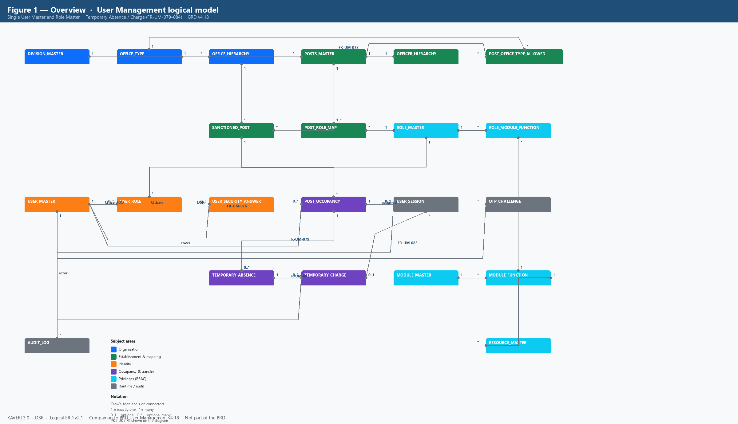
Figure 1. Overview — all logical entities and cardinalities (BRD v4.18)
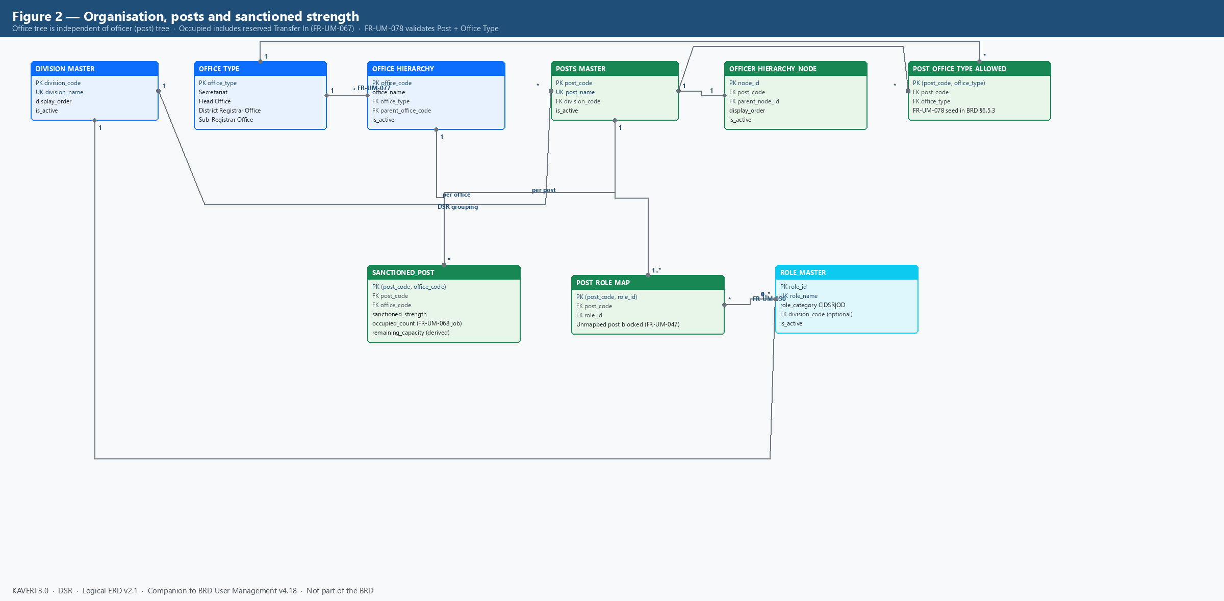
Figure 2. Organisation, posts, sanctioned strength and Post–Role mapping
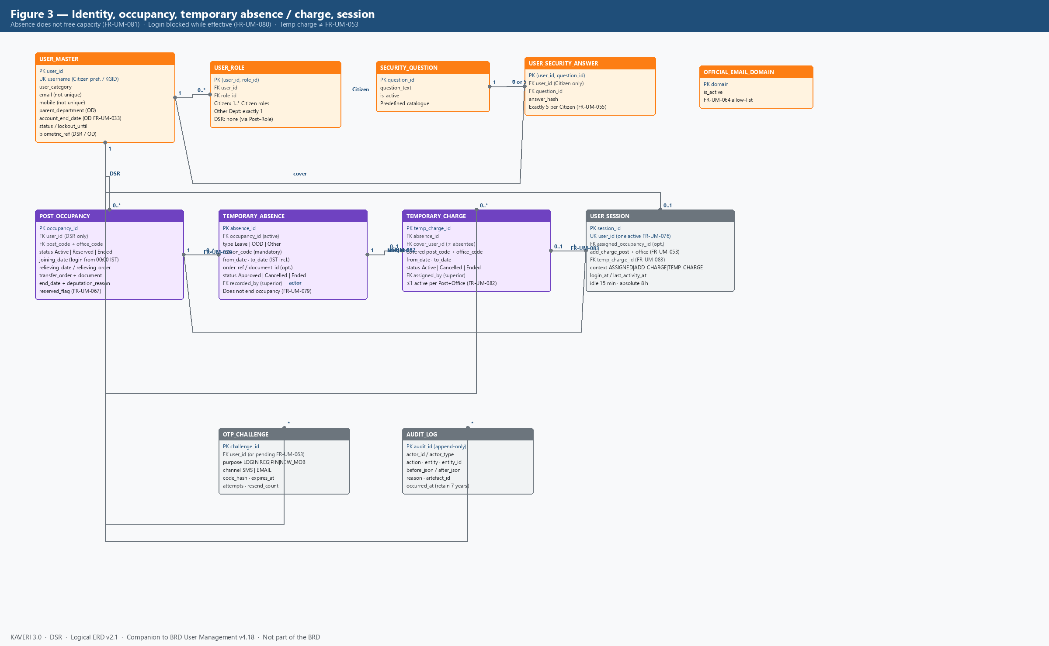
Figure 3. Identity, occupancy, temporary absence / charge, session, OTP and audit
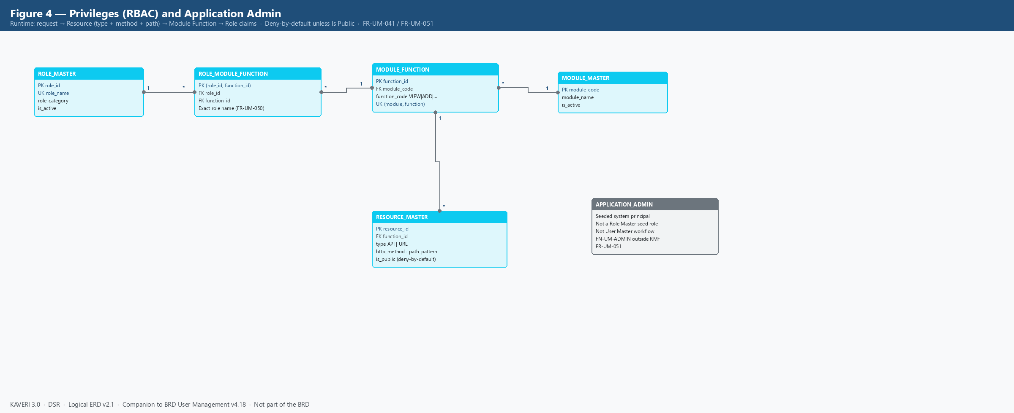
Figure 4. RBAC path Role → Module Function → Resource; Application Admin (FR-UM-051)

4. Subject-area summary
Area | Entities | BRD anchors
Organisation | DIVISION_MASTER, OFFICE_TYPE, OFFICE_HIERARCHY | FR-UM-059, FR-UM-077; §6.5.1, §6.5.8
Establishment | POSTS_MASTER, OFFICER_HIERARCHY_NODE, POST_OFFICE_TYPE_ALLOWED, SANCTIONED_POST, POST_ROLE_MAP | FR-UM-024, FR-UM-043–FR-UM-049, FR-UM-066–FR-UM-068, FR-UM-078; §6.5.3, §6.5.7
Identity | USER_MASTER, USER_ROLE, SECURITY_QUESTION, USER_SECURITY_ANSWER, OFFICIAL_EMAIL_DOMAIN | FR-UM-001–FR-UM-004, FR-UM-016, FR-UM-033–FR-UM-035, FR-UM-055, FR-UM-062–FR-UM-065
Occupancy & transfer | POST_OCCUPANCY (Transfer In / Relieving / deputation End Date as attributes) | FR-UM-026, FR-UM-030, FR-UM-052, FR-UM-057–FR-UM-061, FR-UM-066–FR-UM-068
Temporary absence & charge | TEMPORARY_ABSENCE, TEMPORARY_CHARGE; USER_SESSION.temp_charge_id | FR-UM-079–FR-UM-084; §6.6.6; distinct from FR-UM-053
RBAC | ROLE_MASTER, MODULE_MASTER, MODULE_FUNCTION, RESOURCE_MASTER, ROLE_MODULE_FUNCTION | FR-UM-018, FR-UM-036–FR-UM-042, FR-UM-050–FR-UM-051
Runtime / audit | USER_SESSION, OTP_CHALLENGE, AUDIT_LOG; APPLICATION_ADMIN (not a Role Master entity) | FR-UM-005–FR-UM-013, FR-UM-022, FR-UM-051, FR-UM-069–FR-UM-076

5. Entity catalogue

5.1 DIVISION_MASTER
Enumerated DSR organisational divisions. Free-text division labels are not permitted on new or edited records (FR-UM-077).
Attribute | Type / notes | Constraints
division_code | String, e.g. DIV-ENFORCEMENT | PK
division_name | String | UK; required
display_order | Integer | Seed 1–8
is_active | Boolean | Soft disable

5.2 OFFICE_TYPE
Lookup of Secretariat, Head Office, District Registrar Office, Sub-Registrar Office. Distinct from role names (SRO is an office type, not a Role Master name).
Attribute | Type / notes | Constraints
office_type | Enum / code | PK
display_name | String | Required

5.3 OFFICE_HIERARCHY
Concrete DSR offices. Tree: MS Building (Secretariat, root, OFF-MS-BLDG) → IGR Office (Head Office) → District Registrar Offices → Sub-Registrar Offices (FR-UM-059). Office span for Transfer Out / Transfer In is the session office plus descendants.
Attribute | Type / notes | Constraints
office_code | String, e.g. OFF-SRO-YESH | PK
office_name | String | Required
office_type | FK OFFICE_TYPE | Required
parent_office_code | FK OFFICE_HIERARCHY | Null only for MS Building
is_active | Boolean | Soft disable with audit

5.4 POSTS_MASTER
DSR establishment posts, distinct from Role Master. Division-specific posts (FR-UM-049). Post name is the referential-integrity key used by Post–Role and Hierarchy (FR-UM-050).
Attribute | Type / notes | Constraints
post_code | String, e.g. POST-SR | PK
post_name | String, character-for-character match | UK; required
division_code | FK DIVISION_MASTER | Required (FR-UM-077)
is_active | Boolean | Soft disable

5.5 OFFICER_HIERARCHY_NODE
Reporting tree of Posts (not of people). Each node references a Post; optional parent is also a Post node (FR-UM-043, FR-UM-044). Used for FR-UM-053 additional-charge cascade and Transfer Out / In immediate-parent filter.
Attribute | Type / notes | Constraints
node_id | Surrogate | PK
post_code | FK POSTS_MASTER | UK recommended (one node per post)
parent_node_id | FK self | Null at ACS / Secretary
display_order | Integer | Optional
is_active | Boolean | Soft disable; history retained

5.6 POST_OFFICE_TYPE_ALLOWED
Which Post codes may be sanctioned at which Office Types (FR-UM-078). Example: POST-ACS-SEC only at Secretariat; POST-SR / POST-FDA-ENF / POST-DEO only at Sub-Registrar Office.
Attribute | Type / notes | Constraints
post_code | FK POSTS_MASTER | PK part
office_type | FK OFFICE_TYPE | PK part

5.7 SANCTIONED_POST
Approved headcount per Post at each Office (FR-UM-024, FR-UM-048). Occupied count includes active occupancies and reserved Transfer In (FR-UM-067) and is recalculated by the midnight occupancy refresh job (FR-UM-068). FR-UM-066(a) available capacity = Occupied < Strength. FR-UM-066(b) wholly unoccupied = Occupied = 0 (FR-UM-053).
Attribute | Type / notes | Constraints
post_code | FK POSTS_MASTER | PK part; must have Post–Role mapping (FR-UM-047)
office_code | FK OFFICE_HIERARCHY | PK part
sanctioned_strength | Integer ≥ 0 | Required
occupied_count | Integer, job-maintained | Includes reserved FR-UM-067
remaining_capacity | Derived Strength − Occupied | May be stored or computed

5.8 ROLE_MASTER
Single role catalogue for Citizen, DSR, and Other Department (FR-UM-016, FR-UM-035). Unique role names include division context (FDA (Enforcement), not bare FDA). Application Admin is not a seed row (FR-UM-051).
Attribute | Type / notes | Constraints
role_id | Surrogate | PK
role_name | String | UK; FR-UM-050 exact match
role_category | Citizen | DSR | Other Department | Required
division_code | FK DIVISION_MASTER | Optional; DSR seed grouping
description | String | Optional
is_active | Boolean | Disable blocked if still in use

5.9 POST_ROLE_MAP
One Post may map to multiple Roles only within the same functional scope (FR-UM-047). Sanction or assignment of an unmapped Post is blocked. DSR session privileges come from this mapping for the selected occupancy — not from USER_ROLE.
Attribute | Type / notes | Constraints
post_code | FK POSTS_MASTER | PK part
role_id | FK ROLE_MASTER | PK part; name must match Role Master

5.10 USER_MASTER
Single user store. Username is the only unique login identifier (FR-UM-004, FR-UM-062): preferred Username for Citizens; KGID for DSR Officers and Other Department users. Email and mobile are not unique. No password attribute exists (FR-UM-009).
Attribute | Type / notes | Constraints
user_id | Surrogate | PK
username | Citizen preferred / departmental KGID | UK across all categories
user_category | Public (Citizen) | DSR Officer | Other Department | Required
name_parts | First / middle / last | Required; name locked on standard edit
email | Citizen personal / departmental official | Not unique; FR-UM-064 domain check for DSR/OD
mobile | SMS login OTP target | Not unique
parent_department | String | Other Department only
designation | String | Other Department only
account_end_date | Date | Optional; OD auto-deactivate (FR-UM-033)
status | Active | Suspended | Deactivated | Deactivation requires reason
lockout_until | Timestamp | FR-UM-073 login lock 15 min
reset_lockout_until | Timestamp | FR-UM-056 / FR-UM-073 reset lock 30 min
biometric_ref | UIDAI-compliant token | DSR and Other Department; every login
photo / id_proof_ref | Document store keys | Departmental creation
authorisation_letter_ref | Document store | Other Department should

5.11 USER_ROLE
Direct role assignment for Citizens (one or more Citizen-category roles) and Other Department users (exactly one Other Department role — FR-UM-017 / FR-UM-034). DSR Officers do not receive USER_ROLE rows; their roles are resolved Post occupancy → POST_ROLE_MAP at login (FR-UM-052, FR-UM-038).
Attribute | Type / notes | Constraints
user_id | FK USER_MASTER | PK part
role_id | FK ROLE_MASTER | PK part; Role Category must match User Category

5.12 SECURITY_QUESTION and USER_SECURITY_ANSWER
Citizen self-registration captures five distinct questions from a predefined list; answers stored hashed only (FR-UM-055). Not held for DSR or Other Department users.
Entity | Attribute | Constraints
SECURITY_QUESTION | question_id, question_text, is_active | Predefined catalogue
USER_SECURITY_ANSWER | user_id, question_id, answer_hash | Exactly 5 per Citizen; never displayed

5.13 OFFICIAL_EMAIL_DOMAIN
Optional allow-list for DSR and Other Department official email (FR-UM-064).
Attribute | Type / notes | Constraints
domain | e.g. karnataka.gov.in | PK
is_active | Boolean

5.14 POST_OCCUPANCY
Assignment of a DSR user to a sanctioned Post at an Office. Multiple occupancies per user are allowed. Transfer In, Relieving, reserved handover (FR-UM-067), and deputation End Date (FR-UM-030) are modelled as attributes and status on this entity rather than separate header tables. Login uses occupancies that are Active (Joining Date reached); Reserved occupancies count toward Occupied but cannot be selected until 12:00 AM IST on Joining Date (FR-UM-061).
Attribute | Type / notes | Constraints
occupancy_id | Surrogate | PK
user_id | FK USER_MASTER | User Category = DSR Officer
post_code + office_code | FK SANCTIONED_POST | Must have available capacity unless FR-UM-067
status | Active | Reserved | Ended | Job transitions at midnight IST
joining_date | Date | Transfer In; login from 00:00 IST that day
transfer_order_no / document_id | String / artefact | FR-UM-060
relieving_date | Date | Mapping retained through 23:59 IST of that date
relieving_order_no / document_id | String / artefact | FR-UM-057
end_date | Date | Deputation only (FR-UM-030); not a substitute for relieving
deputation_reason | Code | Mandatory if end_date set
reserved_flag | Boolean | FR-UM-067; counts as occupied immediately
created_by / created_at | Actor + timestamp | Immediate-parent + office-span rules

5.15 USER_SESSION
One active session per Username (FR-UM-076). Idle 15 minutes (FR-UM-074); absolute 8 hours (FR-UM-075). For DSR: session context is exactly one of (a) assigned occupancy (FR-UM-052), (b) additional charge of a wholly unoccupied subordinate post at the same office (FR-UM-053 — session-only, no occupancy row), or (c) temporary charge of an absent Post + Office (FR-UM-083 — FK temp_charge_id). While additional charge or temporary charge is active, Module Function claims come only from that covered post (FR-UM-038).
Attribute | Type / notes | Constraints
session_id | Surrogate | PK
user_id | FK USER_MASTER | UK among active sessions
session_context | ASSIGNED | ADDITIONAL_CHARGE | TEMPORARY_CHARGE | DSR only; null for Citizen / OD
assigned_occupancy_id | FK POST_OCCUPANCY | Required when context = ASSIGNED; optional anchor otherwise
add_charge_post_code | FK POSTS_MASTER | Optional; FR-UM-053; same office as assigned
add_charge_office_code | FK OFFICE_HIERARCHY | Must equal assigned occupancy office
temp_charge_id | FK TEMPORARY_CHARGE | Required when context = TEMPORARY_CHARGE (FR-UM-083)
login_at / last_activity_at / expires_at | Timestamps | IST clock

5.16 TEMPORARY_ABSENCE
Superior-recorded Leave / OOD / Other period linked to an active DSR post occupancy (FR-UM-079). Does not end the occupancy and does not free sanctioned capacity (FR-UM-081). While an Approved absence covers the current IST calendar day (effective absence), login is denied for the Username across all posts (FR-UM-080). Scope to create/amend/cancel matches Transfer Out: office span + immediate-parent post parentage. Cleared after 23:59 IST of to_date by the occupancy refresh job or equivalent day-boundary evaluation (FR-UM-084 / FR-UM-068); superior cancel takes effect immediately.
Attribute | Type / notes | Constraints
absence_id | Surrogate | PK
occupancy_id | FK POST_OCCUPANCY | Must be Active; DSR only
absence_type | Leave | OOD | Other | Required
reason_code | Code / string | Mandatory
from_date | Date (IST) | Inclusive; required
to_date | Date (IST) | Inclusive; ≥ from_date
order_ref / document_id | String / artefact | Optional
status | Approved | Cancelled | Ended | Ended by FR-UM-084 job or cancel
recorded_by | FK USER_MASTER | Hierarchy superior
cancelled_by / cancelled_at | Actor + timestamp | Optional; immediate effect
created_at | Timestamp IST | Required; audit-logged

5.17 TEMPORARY_CHARGE
Superior-assigned mapping of an absent Post + Office to a covering DSR Officer under the same superior (FR-UM-082). May be cross-office within office span. Distinct from FR-UM-053 session additional charge (which requires wholly unoccupied subordinate post at the same office). Cover officer must not be the absentee and must not themselves be under effective absence. At most one Active charge per Post + Office. At FR-UM-052 the cover officer sees temporary-charge rows alongside own assigned posts (FR-UM-083).
Attribute | Type / notes | Constraints
temp_charge_id | Surrogate | PK
absence_id | FK TEMPORARY_ABSENCE | Required; same date window
cover_user_id | FK USER_MASTER | ≠ absentee; DSR Officer
covered_post_code + covered_office_code | From absent occupancy / SANCTIONED_POST | Required
from_date / to_date | Date (IST) | Within or equal to absence window
status | Active | Cancelled | Ended | Ended by FR-UM-084 or cancel
assigned_by | FK USER_MASTER | Hierarchy superior
order_ref / document_id | String / artefact | Optional
created_at / cancelled_at | Timestamps | Audit-logged

5.18 OTP_CHALLENGE
OTP/PIN issuance for login (SMS only), Citizen registration (email + mobile), lost-mobile PIN (email), and new-mobile verification. Policy FR-UM-069–FR-UM-072: 6 digits; login 5 min; registration/PIN 10 min; 3 failures invalidate; 30 s resend; max 3 resends / 15 min.
Attribute | Type / notes | Constraints
challenge_id | Surrogate | PK
user_id | FK USER_MASTER (or pending registration token) | Nullable during FR-UM-063
purpose | LOGIN | REG_EMAIL | REG_MOBILE | RESET_PIN | NEW_MOBILE | Required
channel | SMS | EMAIL | Login OTP never emailed (FR-UM-010)
code_hash | Hash | Never stored clear
expires_at / attempt_count / resend_count | Policy attributes | FR-UM-069–FR-UM-072

5.19 MODULE_MASTER, MODULE_FUNCTION, RESOURCE_MASTER, ROLE_MODULE_FUNCTION
Access path: session roles → ROLE_MODULE_FUNCTION → MODULE_FUNCTION → RESOURCE. Runtime match is Type + Method + Path with most-specific pattern winning; unmatched non-public resources deny (FR-UM-041). Is Public = Yes allows unauthenticated access. Application Admin uses FN-UM-ADMIN outside this mapping (FR-UM-051).
Entity | Key attributes | Notes
MODULE_MASTER | module_code, module_name, is_active | e.g. Marriage Registration, Encumbrance Search
MODULE_FUNCTION | function_id, module_code, function_code | VIEW, ADD, EDIT, APPROVE, SIGN, PRINT, DOWNLOAD, FN-UM-ADMIN
RESOURCE_MASTER | resource_id, function_id, type, method, path_pattern, is_public | Roles do not store raw URL lists
ROLE_MODULE_FUNCTION | role_id, function_id | Role name must match Role Master exactly (FR-UM-050)

5.20 AUDIT_LOG
Append-only log of create/update/delete, login, mobile/email change, lost-mobile reset, Transfer Out / In, additional charge switch, temporary absence / temporary charge create-amend-cancel, occupancy-refresh job, and access denials. Retention at least seven years. Who, when, before/after, reason, artefact id.
Attribute | Type / notes | Constraints
audit_id | Surrogate | PK; no updates/deletes
actor_id / actor_type | User or job / Application Admin | Required
action / entity / entity_id | String | Required
before_json / after_json | JSON | Masked PII (mobile)
reason / artefact_id | String | GO / order document
occurred_at | Timestamp IST | Required

6. Relationship catalogue
Parent | Child | Cardinality | Rule
DIVISION_MASTER | POSTS_MASTER | 1 : * | Every post has a Division Code (FR-UM-077).
DIVISION_MASTER | ROLE_MASTER | 1 : 0..* | Optional grouping for DSR seed roles.
OFFICE_TYPE | OFFICE_HIERARCHY | 1 : * | Four office types only.
OFFICE_HIERARCHY | OFFICE_HIERARCHY | 1 : 0..* | Parent office; MS Building is root.
POSTS_MASTER | OFFICER_HIERARCHY_NODE | 1 : 1 | Every hierarchy node Post exists in Posts Master (FR-UM-044).
OFFICER_HIERARCHY_NODE | OFFICER_HIERARCHY_NODE | 1 : 0..* | Immediate parent post (FR-UM-043).
POSTS_MASTER | POST_OFFICE_TYPE_ALLOWED | 1 : * | FR-UM-078; required before sanction.
OFFICE_TYPE | POST_OFFICE_TYPE_ALLOWED | 1 : * | FR-UM-078.
POSTS_MASTER | SANCTIONED_POST | 1 : * | Strength is per Post per Office.
OFFICE_HIERARCHY | SANCTIONED_POST | 1 : * | Office Type must be allowed for that Post.
POSTS_MASTER | POST_ROLE_MAP | 1 : 1..* | Unmapped post cannot be sanctioned or assigned (FR-UM-047).
ROLE_MASTER | POST_ROLE_MAP | 1 : 0..* | Exact unique role name (FR-UM-050).
USER_MASTER | USER_ROLE | 1 : 0..* | 0 for DSR; 1 for Other Department; 1..* for Citizen.
ROLE_MASTER | USER_ROLE | 1 : 0..* | Role Category must equal User Category (FR-UM-034).
USER_MASTER | USER_SECURITY_ANSWER | 1 : 0 or 5 | Citizens only (FR-UM-055).
SECURITY_QUESTION | USER_SECURITY_ANSWER | 1 : * | Five distinct questions per Citizen.
USER_MASTER | POST_OCCUPANCY | 1 : 0..* | DSR Officers only; multiple posts allowed (FR-UM-026).
SANCTIONED_POST | POST_OCCUPANCY | 1 : 0..* | Blocked when Occupied ≥ Strength unless FR-UM-067 reservation.
POST_OCCUPANCY | TEMPORARY_ABSENCE | 1 : 0..* | FR-UM-079; does not end occupancy; Occupied unchanged (FR-UM-081).
TEMPORARY_ABSENCE | TEMPORARY_CHARGE | 1 : 0..1 active | ≤1 active charge per Post+Office (FR-UM-082).
USER_MASTER | TEMPORARY_CHARGE | 1 : 0..* | Cover officer; ≠ absentee; not under effective absence.
USER_MASTER | USER_SESSION | 1 : 0..1 active | Last-login-wins (FR-UM-076).
POST_OCCUPANCY | USER_SESSION | 1 : 0..* | Assigned post for DSR session (FR-UM-052).
TEMPORARY_CHARGE | USER_SESSION | 1 : 0..* | Session context TEMPORARY_CHARGE (FR-UM-083).
USER_MASTER | OTP_CHALLENGE | 1 : 0..* | Also used pre-account for FR-UM-063.
MODULE_MASTER | MODULE_FUNCTION | 1 : * | FR-UM-039.
MODULE_FUNCTION | RESOURCE_MASTER | 1 : * | FR-UM-040.
ROLE_MASTER | ROLE_MODULE_FUNCTION | 1 : * | Except Application Admin (FR-UM-051).
MODULE_FUNCTION | ROLE_MODULE_FUNCTION | 1 : * | FR-UM-037.
USER_MASTER | AUDIT_LOG | 1 : * | Actor; jobs may write with actor_type = SYSTEM.

7. Category-specific population rules
User Category | Username | USER_ROLE | POST_OCCUPANCY | Security answers | Session extras
Public (Citizen) | Preferred Username (FR-UM-062) | Citizen roles assigned at registration | None | Exactly 5 (FR-UM-055) | No post selection
DSR Officer | KGID = Username (FR-UM-064) | None — roles via Post–Role | 1..* sanctioned posts | None (FR-UM-065) | FR-UM-052 assigned; FR-UM-053 additional charge; FR-UM-083 temporary charge; FR-UM-080 login block if effective absence
Other Department | KGID = Username | Exactly one Other Department role | None (Posts Master N/A) | None | No post selection; optional account_end_date (FR-UM-033)

8. Derived facts (not separate entities)
Fact | How obtained
Session Module Function claims | Citizen/OD: USER_ROLE → RMF. DSR ASSIGNED: occupancy → POST_ROLE_MAP → RMF. DSR ADDITIONAL_CHARGE: add-charge post only (FR-UM-038 / FR-UM-053). DSR TEMPORARY_CHARGE: covered post via POST_ROLE_MAP only (FR-UM-083).
Effective absence | TEMPORARY_ABSENCE status = Approved AND from_date ≤ current IST date ≤ to_date.
Login eligibility (DSR) | Deny if any effective absence exists on any of the user's Active occupancies (FR-UM-080).
FR-UM-052 selectable rows | Active (non-reserved or joining-date-reached) occupancies for user, plus Active TEMPORARY_CHARGE rows where cover_user_id = user.
Office span | Walk OFFICE_HIERARCHY descendants of session office (FR-UM-059).
Immediate-parent transfer / absence filter | OFFICER_HIERARCHY_NODE.parent of the target post = actor session post (FR-UM-057, FR-UM-060, FR-UM-079).
Available capacity FR-UM-066(a) | SANCTIONED_POST.occupied_count < sanctioned_strength (absence does not reduce Occupied — FR-UM-081).
Wholly unoccupied FR-UM-066(b) | occupied_count = 0 (reserved Transfer In counts as occupied; absent-but-occupied is not zero).
Occupied count | Count of POST_OCCUPANCY in Active or Reserved for that Post+Office; refreshed by FR-UM-068 job.

9. Explicit non-entities
Password / credential secret — authentication is OTP (and biometrics for departmental users) only (FR-UM-009).
Application Admin — deployment-seeded system principal with FN-UM-ADMIN; not created via User Master workflow and not a Role Master seed role (FR-UM-051). Shown on the diagram for completeness only.
Primary / Secondary role flags — removed; DSR context is assigned post vs additional charge vs temporary charge (FR-UM-052 / FR-UM-053 / FR-UM-083).
Separate Citizen vs Department user databases — forbidden; one USER_MASTER and one ROLE_MASTER (FR-UM-016).
Absence as vacancy — Temporary Absence must not be modelled as ending occupancy or reducing Occupied (FR-UM-081).

10. Alignment to BRD v4.18
This ERD is a companion to BRD_User_Management_v4.18.docx. If a functional requirement and this model ever diverge, the BRD requirement text prevails until this ERD is revised. Physical LLD / DDL under Finalized BRD/User Management/DDL/ traces to the entity and relationship IDs in sections 5 and 6.
Related documents: BRD-K3-UM-001 v4.18 (requirements) · ERD-K3-UM-001 v2.1 (this document) · DDL/User Management PostgreSQL scripts.

